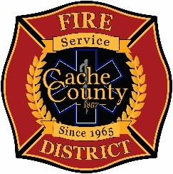
CACHE COUNTY FIRE DISTRICT
BOARD OF TRUSTEES
Kathryn Beus – Board Chair George Daines – Trustee
David Erickson – Trustee Steve Miller – Trustee
Lyndsay Peterson – Trustee Aaron Rudie – Trustee
Larry Jacobsen - Trustee

BOARD OF TRUSTEES MEETING
March 26, 2026
2:00pm

AGENDA

Amended

The Cache County Fire District Board will meet Thursday, March 26, 2026, commencing at 2:00 p.m. in the Cache County Historic Courthouse, Council Conference Room, 199 North Main Logan, Utah 84321.
- CALL TO ORDER:
- ITEMS OF BUSINESS
  - Approval of Agenda – March 26, 2026
  - Approval of Minutes – February 12, 2025
- OATH OF OFFICE FOR ALL TRUSTEES
- NEW ITEMS FOR DISCUSSION
- FINANCIAL SURVEY UPDATE
- 1201 STUDY UPDATE
- CAPTIAL NEEDS/INFRASTRUCTURE ASSESSMENT (TIMELINE AND PROJECT STATUS)
- NEXT MEETING – April 23, 2026 – 2:00pm
- ADJOURN

In compliance with the Americans with Disabilities Act, individuals needing special accommodations (including auxiliary communicative aids and services) during this meeting should notify Janeen Allen, at 755-1850 at least three working days prior to the meeting.

